1. **List**

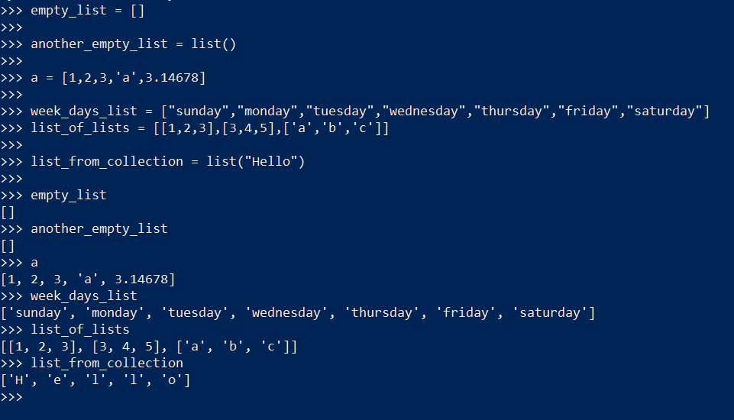

##List creation

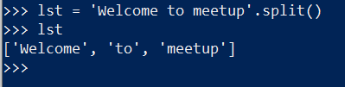 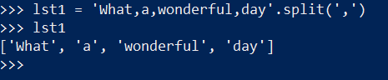

#Make a list using string

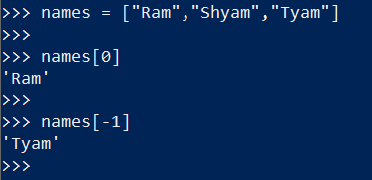

# Access the items in the list

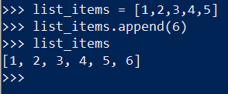

# Using Append Function on list

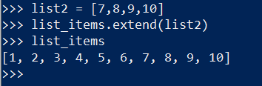

# Using extend function on list

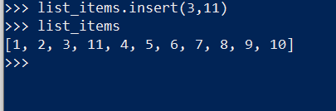

# Using Insert func on list

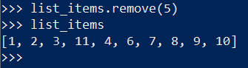

# Using Remove Func on list

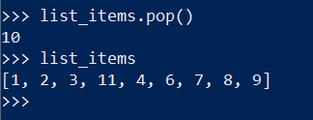

# Using Pop on list

1. **Dictionary**

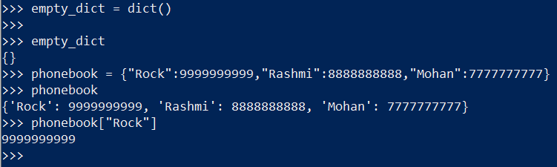

# Dictionary creation

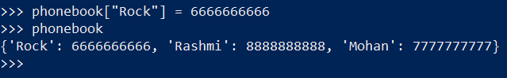

# Accessing values using keys in a dictionary

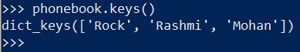

# Using Keys function in a dictionary

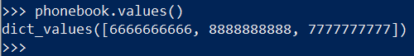

# Using Values function in dictionary



# Using Items function in dictionary

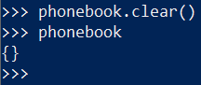

# Using Clear function in dictionary

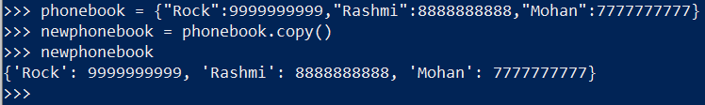

# Using copy function in dictionary

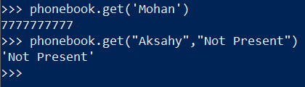

# Using get function on dictionary

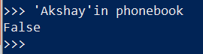

# Using the in keyword for dictionary

1. **Tuples**

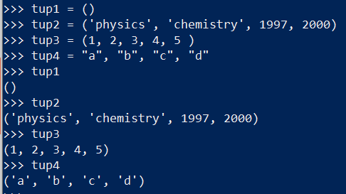

# Tuple Creation Example

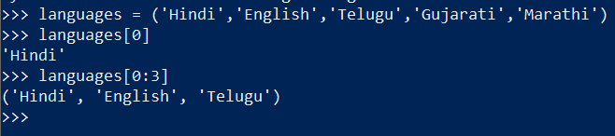

# Accessing elements in tuples

1. **Sets**

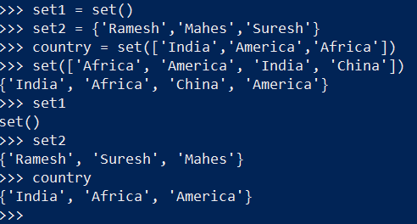

# Set creation

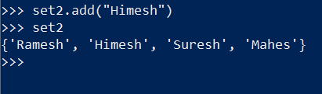

# Using Add function on set

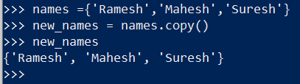

# Using copy function set

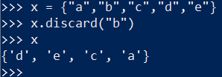

# Using discard function on set

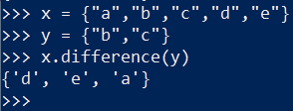

# Using difference function on set

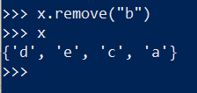

# Using remove function on sets

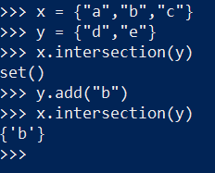

# Using Intersection Function on sets

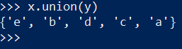

# Using union function on sets

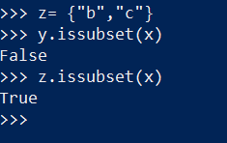

# Using issubset function on sets

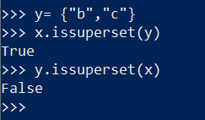

# Using issuperset